- persistence layer is a group of files which is used to communicate between the application and DB.
- The persistence layer deals with persisting (storing and retrieving) data from a data store (such as a database, for example).
- so basically hibernate sessions are the persistence layer which used to copy the values of the data from the database to the java entity class, or mapping the java classes back to the database.

EntityManagerFactory - - - class
EntityManager - - - class
EntityTransaction - - - - class
Persistance.createEntityManagerFactory("Oracle-JPA-PU") - - -class
createEntityManager() - - - method

@Entity
@Table
@Id
@GeneratedValue
@Column
@Transient
@OneToMany(cascade= CascadeType.ALL, mappedBy="empDept")

@OrderBy not working properly in JPA

How does @OrderBy work?
It is not working here in the following code:
Employee.java
package com.semanticbits.pojo;

import java.util.List;

import javax.persistence.CascadeType;
import javax.persistence.Embedded;
import javax.persistence.Entity;
import javax.persistence.GeneratedValue;
import javax.persistence.GenerationType;
import javax.persistence.Id;
import javax.persistence.JoinColumn;
import javax.persistence.OneToMany;
import javax.persistence.OrderBy;

@Entity
public class Employee {

@Id
@GeneratedValue(strategy=GenerationType.IDENTITY)

private int employeeId;
private String name;
private double salary;

@OneToMany(cascade=CascadeType.ALL)
@JoinColumn(name="EMP_ID")
@OrderBy("city DESC")
private List<Address> address;

//setters and getters
public int getEmployeeId() {
return employeeId;
}

public void setEmployeeId(int employeeId) {
this.employeeId = employeeId;
}

public String getName() {
return name;
}

public void setName(String name) {
this.name = name;
}

public double getSalary() {
return salary;
}

public void setSalary(double salary) {
this.salary = salary;
}

public List<Address> getAddress() {
return address;
}

public void setAddress(List<Address> address) {
this.address = address;
}

}
Address.java
package com.semanticbits.pojo;

import javax.persistence.Entity;
import javax.persistence.GeneratedValue;
import javax.persistence.GenerationType;
import javax.persistence.Id;

@Entity
public class Address {

@Id
@GeneratedValue(strategy=GenerationType.IDENTITY)
private int addressId;
private String street;
private String city;
private String state;
private int zipCode;

public String getStreet() {
return street;
}

public void setStreet(String street) {
this.street = street;
}

public String getCity() {
return city;
}

public void setCity(String city) {
this.city = city;
}

public String getState() {
return state;
}

public void setState(String state) {
this.state = state;
}

public int getZipCode() {
return zipCode;
}

public void setZipCode(int zipCode) {
this.zipCode = zipCode;
}

}
persistence.xml
<?xml version="1.0" encoding="UTF-8"?>
<persistence xmlns="http://java.sun.com/xml/ns/persistence"
xmlns:xsi="http://www.w3.org/2001/XMLSchema-instance"
xsi:schemaLocation="http://java.sun.com/xml/ns/persistence
http://java.sun.com/xml/ns/persistence/persistence_1_0.xsd" version="1.0">

<persistence-unit name="orderbyannotationdemo" transaction-type="RESOURCE_LOCAL">
<provider></provider>

<class>com.semanticbits.pojo.Employee</class>
<class>com.semanticbits.pojo.Address</class>

<properties>

<property name="javax.persistence.jdbc.url" value="jdbc:mysql://localhost:3306/shoaib"/>
<property name="javax.persistence.jdbc.driver" value="com.mysql.jdbc.Driver"/>
<property name="javax.persistence.jdbc.user" value="root"/>
<property name="javax.persistence.jdbc.password" value="root"/>
<property name="eclipselink.logging.level" value="FINE"/>
<property name="eclipselink.ddl-generation" value="create-tables"/>

</properties>
</persistence-unit>
</persistence>
This is the test class......check out the city name and it is not storing address values in order in descending order in the ADDRESS table
JPAOrderByAnnotationTest
package com.semanticbits.test;

import java.util.ArrayList;
import java.util.List;

import javax.persistence.EntityManager;
import javax.persistence.EntityManagerFactory;
import javax.persistence.Persistence;

import com.semanticbits.pojo.Address;
import com.semanticbits.pojo.Employee;

public class JPAOrderByAnnotationTest {

/**
* @param args
*/
public static void main(String[] args) {

EntityManagerFactory factory=Persistence.createEntityManagerFactory("orderbyannotationdemo");
EntityManager manager=factory.createEntityManager();

Employee employee=new Employee();
employee.setName("Shoaib");
employee.setSalary(1452365);

Address addressOffice=new Address();
addressOffice.setCity("Hyderabad");
addressOffice.setStreet("Gachibowli");
addressOffice.setState("AP");
addressOffice.setZipCode(500016);

Address addressHome=new Address();
addressHome.setCity("Noida");
addressHome.setStreet("Chandai Chowk");
addressHome.setState("UP");
addressHome.setZipCode(415608);

Address addressCollege=new Address();
addressCollege.setCity("Antartica");
addressCollege.setState("Canada");
addressCollege.setStreet("New York");
addressCollege.setZipCode(402103);

List<Address> addresses=new ArrayList<Address>();
addresses.add(addressHome);
addresses.add(addressOffice);
addresses.add(addressCollege);

employee.setAddress(addresses);

manager.getTransaction().begin();

manager.persist(employee);
manager.getTransaction().commit();

manager.close();

}
}

- Jun 6 '13 at 15:20
add a comment

2 Answers
activeoldestvotes
20
I think you're misunderstanding what the @Orderby annotation actually does. According to the javadoc:
Specifies the ordering of the elements of a collection valued association or element collection at the point when the association or collection is retrieved.
[emphasis added] The annotation does not dictate insertion order. Continuing with your example, if you were to fetch an Employee:
Employee employee = manager.find(Employee.class, employeeId);
List<Address> addresses = employee.getAddress();
Then addresses would be sorted by city in descending order.

Why does JPA have a @Transient annotation?
Ask Question
234
63
Java has the transientkeyword. Why does JPA have @Transient instead of simply using the already existing java keyword?

6 Answers
activeoldestvotes
369
Java's transient keyword is used to denote that a field is not to be serialized, whereas JPA's @Transient annotation is used to indicate that a field is not to be persisted in the database, i.e. their semantics are different.

As others have said, @Transient is used to mark fields which shouldn't be persisted. Consider this short example:
public enum Gender { MALE, FEMALE, UNKNOWN }

@Entity
public Person {
private Gender g;
private long id;

@Id
@GeneratedValue(strategy=GenerationType.AUTO)
public long getId() { return id; }
public void setId(long id) { this.id = id; }

public Gender getGender() { return g; }
public void setGender(Gender g) { this.g = g; }

@Transient
public boolean isMale() {
return Gender.MALE.equals(g);
}

@Transient
public boolean isFemale() {
return Gender.FEMALE.equals(g);
}
}
When this class is fed to the JPA, it persists the gender and id but doesn't try to persist the helper boolean methods - without @Transient the underlying system would complain that the Entity class Person is missing setMale()and setFemale() methods and thus wouldn't persist Person at all.

Hibernate JPA Annotations - Contents:
Annotation | Package Detail/Import statement
@Entity | import javax.persistence.Entity;
@Table | import javax.persistence.Table;
@Column | import javax.persistence.Column;
@Id | import javax.persistence.Id;
@GeneratedValue | import javax.persistence.GeneratedValue;
@Version | import javax.persistence.Version;
@OrderBy | import javax.persistence.OrderBy;
@Transient | import javax.persistence.Transient;
@Lob | import javax.persistence.Lob;
Hibernate Association Mapping Annotations
@OneToOne | import javax.persistence.OneToOne;
@ManyToOne | import javax.persistence.ManyToOne;
@OneToMany | import javax.persistence.OneToMany;
@ManyToMany | import javax.persistence.ManyToMany;
@PrimaryKeyJoinColumn | import javax.persistence.PrimaryKeyJoinColumn;
@JoinColumn | import javax.persistence.JoinColumn;
@JoinTable | import javax.persistence.JoinTable;
@MapsId | import javax.persistence.MapsId;
Hibernate Inheritance Mapping Annotations
@Inheritance | import javax.persistence.Inheritance;
@DiscriminatorColumn | import javax.persistence.DiscriminatorColumn;
@DiscriminatorValue | import javax.persistence.DiscriminatorValue;

@Entity
Annotate all your entity beans with @Entity.
1  2  3  4 | @Entity  public class Company implements Serializable {  ...  }

@Table
Specify the database table this Entity maps to using the name attribute of @Table annotation. In the example below, the data will be stored in 'company' table in the database.
1  2  3  4  5 | @Entity  @Table(name = "company")  public class Company implements Serializable {  ...  }

@Column
Specify the column mapping using @Column annotation.
1  2  3  4  5  6  7  8  9 | @Entity  @Table(name = "company")  public class Company implements Serializable {  @Column(name = "name")  private String name;  ...  }

@Id
Annotate the id column using @Id.
1  2  3  4  5  6  7  8  9  10 | @Entity  @Table(name = "company")  public class Company implements Serializable {  @Id  @Column(name = "id")  private int id;  ...  }

@GeneratedValue
Let database generate (auto-increment) the id column.
1  2  3  4  5  6  7  8  9  10  11 | @Entity  @Table(name = "company")  public class Company implements Serializable {  @Id  @Column(name = "id")  @GeneratedValue  private int id;  ...  }

@Version
Control versioning or concurrency using @Version annotation.
1  2  3  4  5  6  7  8  9  10 | @Entity  @Table(name = "company")  public class Company implements Serializable {  @Version  @Column(name = "version")  private Date version;  ...  }

@OrderBy
Sort your data using @OrderBy annotation. In example below, it will sort all contacts in a company by their firstname in ascending order.
1  2 | @OrderBy("firstName asc")  private Set contacts;

@Transient
Annotate your transient properties with @Transient.

@Lob
Annotate large objects with @Lob.

Hibernate Association Mapping Annotations

Example App DB Schema
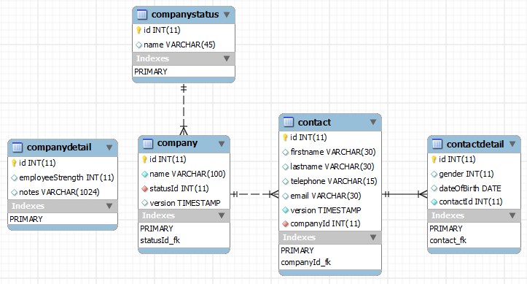
The database for this tutorial is designed to illustrate various association mapping concepts.
In RDBMS implementations, entities are joined using the following ways:
- Shared Primary Key
- Foreign Key
- Association Table
In our example app,
- Tables company and companyDetail have shared values for primary key. It is a one-to-one assoication.
- Tables contact and contactDetail are linked through a foreign key. It is also a one to one association.
- Tables contact and company are linked through a foriegn key in many-to-one association with contact being the owner.
- Tables company and companyStatus are linked through a foreign key in many-to-one association with company being the owner.

@OneToOne
 | - Use @PrimaryKeyJoinColumn for associated entities sharing the same primary key.  - Use @JoinColumn & @OneToOne mappedBy attribute when foreign key is held by one of the entities.  - Use @JoinTable and mappedBy entities linked through an association table.  - Persist two entities with shared key using @MapsId
For entities Company and CompanyDetail sharing the same primary key, we can associate them using @OneToOne and @PrimaryKeyJoinColumn as shown in the example below.
Notice that the id property of CompanyDetail is NOT annotated with @GeneratedValue. It will be populated by id value of Company.
1  2  3  4  5  6  7  8  9  10  11  12  13  14  15  16  17  18  19  20  21  22  23  24  25  26 | @Entity  @Table(name = "company")  public class Company implements Serializable {  @Id  @Column(name = "id")  @GeneratedValue  private int id;  @OneToOne(cascade = CascadeType.MERGE)  @PrimaryKeyJoinColumn  private CompanyDetail companyDetail;  ...  }  @Entity  @Table(name = "companyDetail")  public class CompanyDetail implements Serializable {  @Id  @Column(name = "id")  private int id;  ...  }
For entities Contact and ContactDetail linked through a foriegn key, we can use @OneToOne and @JoinColumn annotations. In example below, the id genereated for Contact will be mapped to 'contact_id' column of ContactDetail table. Please note the usage of @MapsId for the same.
1  2  3  4  5  6  7  8  9  10  11  12  13  14  15  16  17  18  19  20  21  22  23  24  25  26  27  28  29  30  31 | @Entity  @Table(name = "contactDetail")  public class ContactDetail implements Serializable {  @Id  @Column(name = "id")  @GeneratedValue  private int id;  @OneToOne  @MapsId  @JoinColumn(name = "contactId")  private Contact contact;  ...  }  @Entity  @Table(name = "contact")  public class Contact implements Serializable {  @Id  @Column(name = "ID")  @GeneratedValue  private Integer id;  @OneToOne(mappedBy = "contact", cascade = CascadeType.ALL)  private ContactDetail contactDetail;  ....  }
Also note that the relationship between Company and CompanyDetail is uni-directional. On the other hand, the relationship between Contact and Contact Detail is bi-directional and that can be achieved using 'mappedBy' attribute.
The rationale to have one relationship as uni-directional and other as bi-directional in this tutorial is to illustrate both concepts and their usage. You can opt for uni-directional or bi-directional relationships to suit your needs.

@ManyToOne
- Use @JoinColumn when foreign key is held by one of the entities.
- Use @JoinTable for entities linked through an association table.
The two examples below illustrate many-to-one relationships. Contact to Company and Company to CompanyStatus. Many contacts can belong to a company. Similary many companies can share the same status (Lead, Prospect, Customer) - there will be many companies that are currently leads.
1  2  3  4  5  6  7  8  9  10  11  12  13  14  15  16  17  18  19  20  21  22  23 | @Entity  @Table(name = "contact")  public class Contact implements Serializable {  @ManyToOne  @JoinColumn(name = "companyId")  private Company company;  ...  }  @Entity  @Table(name = "company")  public class Company implements Serializable {  @ManyToOne  @JoinColumn(name = "statusId")  private CompanyStatus status;  ...  }

@OneToMany
- Use mappedBy attribute for bi-directional associations with ManyToOne being the owner.
- OneToMany being the owner or unidirectional with foreign key - try to avoid such associations but can be achieved with @JoinColumn
- @JoinTable for Unidirectional with association table
Please see the many-to-one relationship between Contact and Company above. Company to Contact will be a one-to-many relationship. The owner of this relationship is Contact and hence we will use 'mappedBy' attribute in Company to make it bi-directional relationship.
1  2  3  4  5  6  7  8  9  10  11 | @Entity  @Table(name = "company")  public class Company implements Serializable {  @OneToMany(mappedBy = "company", fetch = FetchType.EAGER)  @OrderBy("firstName asc")  private Set contacts;  ...  }
Again, for this tutorial, we have kept Company to CompanyStatus relationship as uni-directional.

@ManyToMany
- Use @JoinTable for entities linked through an association table.
- Use mappedBy attribute for bi-directional association.

@PrimaryKeyJoinColumn
@PrimaryKeyJoinColumn annotation is used for associated entities sharing the same primary key. See OneToOne section for details.
1  2  3  4  5  6  7  8  9  10  11  12  13  14  15 | @Entity  @Table(name = "company")  public class Company implements Serializable {  @Id  @Column(name = "id")  @GeneratedValue  private int id;  @OneToOne(cascade = CascadeType.MERGE)  @PrimaryKeyJoinColumn  private CompanyDetail companyDetail;  ...  }

@JoinColumn
Use @JoinColumn annotation for one-to-one or many-to-one associations when foreign key is held by one of the entities. We can use @OneToOne or @ManyToOne mappedBy attribute for bi-directional relations. Also see OneToOne and ManyToOne sections for more details.
1  2  3 | @ManyToOne  @JoinColumn(name = "statusId")  private CompanyStatus status;

@JoinTable
Use @JoinTable and mappedBy for entities linked through an association table.

@MapsId
Persist two entities with shared key (when one entity holds a foreign key to the other) using @MapsId annotation. See OneToOne section for details.
1  2  3  4 | @OneToOne  @MapsId  @JoinColumn(name = "contactId")  private Contact contact;

Hibernate Inheritance Mapping Annotations
To understand Inheritance Mapping annotations, you must first understand Inheritance Mapping in Hiberate in detail. Once you understand Inheritance mapping concepts, please review below for annotations to be used.
- table per class hierarchy - single table per Class Hierarchy Strategy: the <subclass> element in Hibernate
1  2  3  4  5  6  7  8  9  10 | @Entity  @Inheritance(strategy=InheritanceType.SINGLE_TABLE)  @DiscriminatorColumn(name="planetype", discriminatorType=DiscriminatorType.STRING )  @DiscriminatorValue("Plane")  public class Plane { ... }  @Entity  @DiscriminatorValue("A320")  public class A320 extends Plane { ... }
- table per class/subclass - joined subclass Strategy: the <joined-subclass> element in Hibernate
1  2  3  4  5  6  7 | @Entity  @Inheritance(strategy=InheritanceType.JOINED)  public class Boat implements Serializable { ... }  @Entity  @PrimaryKeyJoinColumn  public class Ferry extends Boat { ... }
- table per concrete class - table per Class Strategy: the <union-class> element in Hibernate
1  2  3 | @Entity  @Inheritance(strategy = InheritanceType.TABLE_PER_CLASS)  public class Flight implements Serializable { ... }
 | Note: This strategy does not support the IDENTITY generator strategy: the id has to be shared across several tables. Consequently, when using this strategy, you should not use AUTO nor IDENTITY.

@Inheritance
See Hibernate Inheritance Mapping Annotations section for details.
1  2 | @Entity  @Inheritance(strategy=InheritanceType.SINGLE_TABLE)

@DiscriminatorColumn
See Hibernate Inheritance Mapping Annotations section for details.
1  2  3 | @Entity  @Inheritance(strategy=InheritanceType.SINGLE_TABLE)  @DiscriminatorColumn(name="planetype", discriminatorType=DiscriminatorType.STRING )

@DiscriminatorValue
See Hibernate Inheritance Mapping Annotations section for details.
1  2  3  4  5  6  7  8  9  10 | @Entity  @Inheritance(strategy=InheritanceType.SINGLE_TABLE)  @DiscriminatorColumn(name="planetype", discriminatorType=DiscriminatorType.STRING )  @DiscriminatorValue("Plane")  public class Plane { ... }  @Entity  @DiscriminatorValue("A320")  public class A320 extends Plane { ... }

What are the possible values of the #Hibernate hbm2ddl.auto configuration and what do they do
hibernate.hbm2ddl.auto Automatically validates or exports schema DDL to the database when the SessionFactory is created. With create-drop, the database schema will be dropped when the SessionFactory is closed explicitly.
e.g. validate | update | create | create-drop
So the list of possible options are,
- validate: validate the schema, makes no changes to the database.
- update: update the schema.
- create: creates the schema, destroying previous data.
- create-drop: drop the schema when the SessionFactory is closed explicitly, typically when the application is stopped.

How does @OrderBy work?
It is not working here in the following code:
Employee.java
package com.semanticbits.pojo;

import java.util.List;

import javax.persistence.CascadeType;
import javax.persistence.Embedded;
import javax.persistence.Entity;
import javax.persistence.GeneratedValue;
import javax.persistence.GenerationType;
import javax.persistence.Id;
import javax.persistence.JoinColumn;
import javax.persistence.OneToMany;
import javax.persistence.OrderBy;

@Entity
public class Employee {

@Id
@GeneratedValue(strategy=GenerationType.IDENTITY)

private int employeeId;
private String name;
private double salary;

@OneToMany(cascade=CascadeType.ALL)
@JoinColumn(name="EMP_ID")
@OrderBy("city DESC")
private List<Address> address;

//setters and getters
public int getEmployeeId() {
return employeeId;
}

public void setEmployeeId(int employeeId) {
this.employeeId = employeeId;
}

public String getName() {
return name;
}

public void setName(String name) {
this.name = name;
}

public double getSalary() {
return salary;
}

public void setSalary(double salary) {
this.salary = salary;
}

public List<Address> getAddress() {
return address;
}

public void setAddress(List<Address> address) {
this.address = address;
}

}
Address.java
package com.semanticbits.pojo;

import javax.persistence.Entity;
import javax.persistence.GeneratedValue;
import javax.persistence.GenerationType;
import javax.persistence.Id;

@Entity
public class Address {

@Id
@GeneratedValue(strategy=GenerationType.IDENTITY)
private int addressId;
private String street;
private String city;
private String state;
private int zipCode;

public String getStreet() {
return street;
}

public void setStreet(String street) {
this.street = street;
}

public String getCity() {
return city;
}

public void setCity(String city) {
this.city = city;
}

public String getState() {
return state;
}

public void setState(String state) {
this.state = state;
}

public int getZipCode() {
return zipCode;
}

public void setZipCode(int zipCode) {
this.zipCode = zipCode;
}

}
persistence.xml
<?xml version="1.0" encoding="UTF-8"?>
<persistence xmlns="http://java.sun.com/xml/ns/persistence"
xmlns:xsi="http://www.w3.org/2001/XMLSchema-instance"
xsi:schemaLocation="http://java.sun.com/xml/ns/persistence
http://java.sun.com/xml/ns/persistence/persistence_1_0.xsd" version="1.0">

<persistence-unit name="orderbyannotationdemo" transaction-type="RESOURCE_LOCAL">
<provider></provider>

<class>com.semanticbits.pojo.Employee</class>
<class>com.semanticbits.pojo.Address</class>

<properties>

<property name="javax.persistence.jdbc.url" value="jdbc:mysql://localhost:3306/shoaib"/>
<property name="javax.persistence.jdbc.driver" value="com.mysql.jdbc.Driver"/>
<property name="javax.persistence.jdbc.user" value="root"/>
<property name="javax.persistence.jdbc.password" value="root"/>
<property name="eclipselink.logging.level" value="FINE"/>
<property name="eclipselink.ddl-generation" value="create-tables"/>

</properties>
</persistence-unit>
</persistence>
This is the test class......check out the city name and it is not storing address values in order in descending order in the ADDRESS table

JPAOrderByAnnotationTest
package com.semanticbits.test;

import java.util.ArrayList;
import java.util.List;

import javax.persistence.EntityManager;
import javax.persistence.EntityManagerFactory;
import javax.persistence.Persistence;

import com.semanticbits.pojo.Address;
import com.semanticbits.pojo.Employee;

public class JPAOrderByAnnotationTest {

/**
* @param args
*/
public static void main(String[] args) {

EntityManagerFactory factory=Persistence.createEntityManagerFactory("orderbyannotationdemo");
EntityManager manager=factory.createEntityManager();

Employee employee=new Employee();
employee.setName("Shoaib");
employee.setSalary(1452365);

Address addressOffice=new Address();
addressOffice.setCity("Hyderabad");
addressOffice.setStreet("Gachibowli");
addressOffice.setState("AP");
addressOffice.setZipCode(500016);

Address addressHome=new Address();
addressHome.setCity("Noida");
addressHome.setStreet("Chandai Chowk");
addressHome.setState("UP");
addressHome.setZipCode(415608);

Address addressCollege=new Address();
addressCollege.setCity("Antartica");
addressCollege.setState("Canada");
addressCollege.setStreet("New York");
addressCollege.setZipCode(402103);

List<Address> addresses=new ArrayList<Address>();
addresses.add(addressHome);
addresses.add(addressOffice);
addresses.add(addressCollege);

employee.setAddress(addresses);

manager.getTransaction().begin();

manager.persist(employee);
manager.getTransaction().commit();

manager.close();

}
}
I think you're misunderstanding what the @Orderby annotation actually does. According to the javadoc:
Specifies the ordering of the elements of a collection valued association or element collection at the point when the association or collection is retrieved.
[emphasis added] The annotation does not dictate insertion order. Continuing with your example, if you were to fetch an Employee:
Employee employee = manager.find(Employee.class, employeeId);
List<Address> addresses = employee.getAddress();
Then addresses would be sorted by city in descending order.

@MappedBy
in a bidirectional relationship, one of the sides (and only one) has to be the owner. The owner is responsible for the association column(s) update. To declare a side as not responsible for the relationship, the attribute mappedBy is used. ‘mappedBy’ refers to the property name of the association on the owner side.

@JoinColumn Annotation Explained
Last modified: October 28, 2018
by baeldung
- Persistence
- Hibernate
- JPA

I just announced the new Spring Boot 2 material, coming in REST With Spring:
>> CHECK OUT THE COURSE

1. Introduction
The annotation javax.persistence.JoinColumn marks a column for as a join column for an entity association or an element collection.
In this quick tutorial, we’ll show some examples of basic @JoinCloumn usage.

2. @OneToOne Mapping Example
The @JoinColumn annotation combined with a @OneToOne mapping indicates that a given column in the owner entity refers to a primary key in the reference entity:
1  2  3  4  5  6 | @Entity  public class Office {  @OneToOne(fetch = FetchType.LAZY)  @JoinColumn(name = "addressId")  private Address address;  }
The above code example will create a foreign key linking the Office entity with the primary key from the Address entity. The name of the foreign key column in the Office entity is specified by name property.

3. @OneToMany Mapping Example
When using a @OneToMany mapping we can use the mappedBy parameter to indicate that the given column is owned by another entity.
1  2  3  4  5  6  7  8  9  10  11  12  13  14  15  16  17 | @Entity  public class Employee {  @Id  private Long id;  @OneToMany(fetch = FetchType.LAZY, mappedBy = "employee")  private List<Email> emails;  }  @Entity  public class Email {  @ManyToOne(fetch = FetchType.LAZY)  @JoinColumn(name = "employee_id")  private Employee employee;  }
In the above example, Email (the owner entity) has a join column employee_id that stores the id value and has a foreign key to the Employee entity.

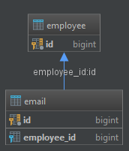

4. @JoinColumns
In situations when we want to create multiple join columns we can use the @JoinColumnsannotation:
1  2  3  4  5  6  7  8  9 | @Entity  public class Office {  @ManyToOne(fetch = FetchType.LAZY)  @JoinColumns({  @JoinColumn(name="ADDR_ID", referencedColumnName="ID"),  @JoinColumn(name="ADDR_ZIP", referencedColumnName="ZIP")  })  private Address address;  }
The above example will create two foreign keys pointing to ID and ZIP columns in the Address entity:
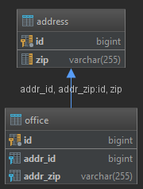

5. Conclusion
In this article, we’ve learned how to use the @JoinColumn annotation. We’ve shown examples how to create both single entity association and element collection.

JPA “@JoinTable” annotation

4 Answers
activeoldestvotes
289
EDIT 2017-04-29: As pointed to by some of the commenters, the JoinTable example does not need the mappedBy annotation attribute. In fact, recent versions of Hibernate refuse to start up by printing the following error:
org.hibernate.AnnotationException:
Associations marked as mappedBy must not define database mappings
like @JoinTable or @JoinColumn

Let's pretend that you have an entity named Project and another entity named Task and each project can have many tasks.
You can design the database schema for this scenario in two ways.
The first solution is to create a table named Project and another table named Task and add a foreign key column to the task table named project_id:
Project Task
------- ----
id id
name name
project_id
This way, it will be possible to determine the project for each row in the task table. If you use this approach, in your entity classes you won't need a join table:
@Entity
public class Project {

@OneToMany(mappedBy = "project")
private Collection<Task> tasks;

}

@Entity
public class Task {

@ManyToOne
private Project project;

}
The other solution is to use a third table, e.g. Project_Tasks, and store the relationship between projects and tasks in that table:
Project Task Project_Tasks
------- ---- -------------
id id project_id
name name task_id
The Project_Tasks table is called a "Join Table". To implement this second solution in JPA you need to use the @JoinTable annotation. For example, in order to implement a uni-directional one-to-many association, we can define our entities as such:
Project entity:
@Entity
public class Project {

@Id
@GeneratedValue
private Long pid;

private String name;

@JoinTable
@OneToMany
private List<Task> tasks;

public Long getPid() {
return pid;
}

public void setPid(Long pid) {
this.pid = pid;
}

public String getName() {
return name;
}

public void setName(String name) {
this.name = name;
}

public List<Task> getTasks() {
return tasks;
}

public void setTasks(List<Task> tasks) {
this.tasks = tasks;
}
}
Task entity:
@Entity
public class Task {

@Id
@GeneratedValue
private Long tid;

private String name;

public Long getTid() {
return tid;
}

public void setTid(Long tid) {
this.tid = tid;
}

public String getName() {
return name;
}

public void setName(String name) {
this.name = name;
}

}
This will create the following database structure: 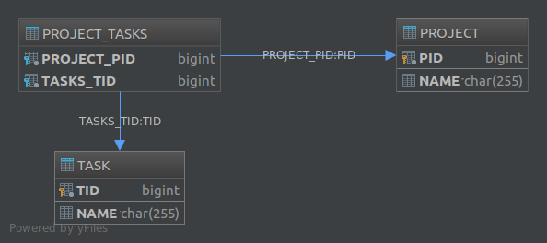

The @JoinTable annotation also lets you customize various aspects of the join table. For example, had we annotated the tasks property like this:
@JoinTable(
name = "MY_JT",
joinColumns = @JoinColumn(
name = "PROJ_ID",
referencedColumnName = "PID"
),
inverseJoinColumns = @JoinColumn(
name = "TASK_ID",
referencedColumnName = "TID"
)
)
@OneToMany
private List<Task> tasks;
The resulting database would have become:

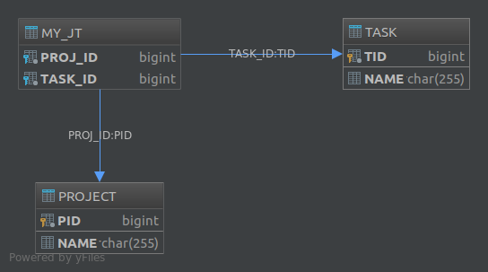

Finally, if you want to create a schema for a many-to-many association, using a join table is the only available solution.

-----

It's the only solution to map a ManyToMany association : you need a join table between the to entities tables to map the association.
It's also used for OneToMany (usually unidirectional) associations, when you don't want to add a foreign key in the table of the many side, and thus keep it independant of the one side.
Search for @JoinTable in the hibernate documentation for explanations and examples.

It lets you handle Many to Many relationship. Example:
Table 1: post

post has following columns
____________________
| ID | DATE |
|_________|_________|
| | |
|_________|_________|

Table 2: user

user has the following columns:

____________________
| ID |NAME |
|_________|_________|
| | |
|_________|_________|
Join Table lets you create a mapping using:
@JoinTable(
name="USER_POST",
joinColumns=@JoinColumn(name="USER_ID", referencedColumnName="ID"),
inverseJoinColumns=@JoinColumn(name="POST_ID", referencedColumnName="ID"))
will create a table:
____________________
| USER_ID| POST_ID |
|_________|_________|
| | |
|_________|_________|
shareimprove this answer

JPA - @JoinTable Examples | Top of Form  Bottom of Form
  
JPA JAVA EE

@JoinTable can be used to map following associations to database table: bidirectional many-to-one/one-to-many, unidirectional many-to-one, and one-to-one (both bidirectional and unidirectional) associations.

import javax.persistence.*;
import java.util.List;
@Entity
public class EntityA {
@Id
@GeneratedValue
private int myIdA;
@OneToMany
@JoinTable(name = "MY_JOIN_TABLE",
joinColumns = {@JoinColumn(name = "MY_ENTITY_A_FK")},
inverseJoinColumns = {@JoinColumn(name = "MY_ENTITY_B_FK")}
)
private List<EntityB> entityBList;
public List<EntityB> getEntityBList() {
return entityBList;
}
public void setEntityBList(List<EntityB> entityBList) {
this.entityBList = entityBList;
}
@Override
public String toString() {
return "EntityA{" +
"myIdA=" + myIdA +
", entityBList=" + entityBList +
'}';
}
}
Original Post

@Entity
public class EntityA {
@Id
@GeneratedValue
private int myIdA;
private String strA;
@OneToMany
@JoinTable(name = "MY_JOIN_TABLE",
joinColumns = {@JoinColumn(name = "MY_ENTITY_A_FK", referencedColumnName = "myIdA")},
inverseJoinColumns = {@JoinColumn(name = "MY_ENTITY_B_FK", referencedColumnName = "myIdB")}
)
private List<EntityB> entityBList;
public String getStrA() {
return strA;
}
public void setStrA(String strA) {
this.strA = strA;
}
public List<EntityB> getEntityBList() {
return entityBList;
}
public void setEntityBList(List<EntityB> entityBList) {
this.entityBList = entityBList;
}
@Override
public String toString() {
return "EntityA{" +
"myIdA=" + myIdA +
", strA='" + strA + '\'' +
'}';
}
}

@Entity
public class EntityB {
@Id
@GeneratedValue
private int myIdB;
private String strB;
@ManyToOne
@JoinTable(name = "MY_JOIN_TABLE",
joinColumns = {@JoinColumn(name = "MY_ENTITY_B_FK", insertable = false,
updatable = false, referencedColumnName = "myIdB")},
inverseJoinColumns = {@JoinColumn(name = "MY_ENTITY_A_FK", insertable = false,
updatable = false, referencedColumnName = "myIdA")}
)
private EntityA refEntityA;
public String getStrB() {
return strB;
}
public void setStrB(String strB) {
this.strB = strB;
}
public EntityA getRefEntityA() {
return refEntityA;
}
public void setRefEntityA(EntityA refEntityA) {
this.refEntityA = refEntityA;
}
@Override
public String toString() {
return "EntityB{" +
"myIdB=" + myIdB +
", strB='" + strB + '\'' +
'}';
}
}
Original Post

@OneToOne unidirectional with @JoinTable:

@Entity
public class EntityA {
@Id
@GeneratedValue
private int myIdA;
private String stringA;
@OneToOne
@JoinTable(name = "MY_JOIN_TABLE",
joinColumns = {
@JoinColumn(name = "ENTITYA_FK", referencedColumnName = "myIdA")
},
inverseJoinColumns = {
@JoinColumn(name = "ENTITYB_FK", referencedColumnName = "myIdB", unique = true)
}
)
private EntityB entityB;
.............
}

@Entity
public class EntityB {
@Id
@GeneratedValue
private int myIdB;
private String stringB;
.............
}
Original Post

@OneToOne bidirectional with @JoinTable:

@Entity
public class EntityA {
@Id
@GeneratedValue
private int myIdA;
private String stringA;
@OneToOne
@JoinTable(name = "MY_JOIN_TABLE",
joinColumns = {
@JoinColumn(name = "ENTITYA_FK", referencedColumnName = "myIdA")
},
inverseJoinColumns = {
@JoinColumn(name = "ENTITYB_FK", referencedColumnName = "myIdB", unique = true)
}
)
private EntityB entityB;
.............
}

@Entity
public class EntityB {
@Id
@GeneratedValue
private int myIdB;
private String stringB;
@OneToOne(mappedBy = "entityB")
private EntityA entityA;
.............
}
Original Post

@Entity
public class Employee {
@Id
@GeneratedValue
private long id;
private String name;
@OneToMany
@JoinTable(name = "ASSIGNED_TASKS",
joinColumns = {@JoinColumn(name = "EMPLOYEE_FK")},
inverseJoinColumns = {@JoinColumn(name = "TASK_FK")})
@MapKeyColumn(name = "TASK_DATE")
private Map<Date, Task> tasks;
.............
}

@Entity
public class Task {
@Id
@GeneratedValue
private long id;
private String name;
private String description;
.............
}

Chapter 24. Best Practices
Write fine-grained classes and map them using <component>:
Use an Address class to encapsulate street, suburb, state, postcode. This encourages code reuse and simplifies refactoring.
Declare identifier properties on persistent classes:
Hibernate makes identifier properties optional. There are a range of reasons why you should use them. We recommend that identifiers be 'synthetic', that is, generated with no business meaning.
Identify natural keys:
Identify natural keys for all entities, and map them using <natural-id>. Implement equals() andhashCode() to compare the properties that make up the natural key.
Place each class mapping in its own file:
Do not use a single monolithic mapping document. Map com.eg.Foo in the file com/eg/Foo.hbm.xml. This makes sense, particularly in a team environment.
Load mappings as resources:
Deploy the mappings along with the classes they map.
Consider externalizing query strings:
This is recommended if your queries call non-ANSI-standard SQL functions. Externalizing the query strings to mapping files will make the application more portable.
Use bind variables.
As in JDBC, always replace non-constant values by "?". Do not use string manipulation to bind a non-constant value in a query. You should also consider using named parameters in queries.
Do not manage your own JDBC connections:
Hibernate allows the application to manage JDBC connections, but his approach should be considered a last-resort. If you cannot use the built-in connection providers, consider providing your own implementation of org.hibernate.connection.ConnectionProvider.
Consider using a custom type:
Suppose you have a Java type from a library that needs to be persisted but does not provide the accessors needed to map it as a component. You should consider implementing org.hibernate.UserType. This approach frees the application code from implementing transformations to/from a Hibernate type.
Use hand-coded JDBC in bottlenecks:
In performance-critical areas of the system, some kinds of operations might benefit from direct JDBC. Do not assume, however, that JDBC is necessarily faster. Please wait until you know something is a bottleneck. If you need to use direct JDBC, you can open a Hibernate Session and usingfile:///usr/share/doc/HTML/en-US/index.html that JDBC connection. This way you can still use the same transaction strategy and underlying connection provider.
Understand Session flushing:
Sometimes the Session synchronizes its persistent state with the database. Performance will be affected if this process occurs too often. You can sometimes minimize unnecessary flushing by disabling automatic flushing, or even by changing the order of queries and other operations within a particular transaction.
In a three tiered architecture, consider using detached objects:
When using a servlet/session bean architecture, you can pass persistent objects loaded in the session bean to and from the servlet/JSP layer. Use a new session to service each request. Use Session.merge()or Session.saveOrUpdate() to synchronize objects with the database.
In a two tiered architecture, consider using long persistence contexts:
Database Transactions have to be as short as possible for best scalability. However, it is often necessary to implement long running application transactions, a single unit-of-work from the point of view of a user. An application transaction might span several client request/response cycles. It is common to use detached objects to implement application transactions. An appropriate alternative in a two tiered architecture, is to maintain a single open persistence contact session for the whole life cycle of the application transaction. Then simply disconnect from the JDBC connection at the end of each request and reconnect at the beginning of the subsequent request. Never share a single session across more than one application transaction or you will be working with stale data.
Do not treat exceptions as recoverable:
This is more of a necessary practice than a "best" practice. When an exception occurs, roll back the Transaction and close the Session. If you do not do this, Hibernate cannot guarantee that in-memory state accurately represents the persistent state. For example, do not use Session.load() to determine if an instance with the given identifier exists on the database; use Session.get() or a query instead.
Prefer lazy fetching for associations:
Use eager fetching sparingly. Use proxies and lazy collections for most associations to classes that are not likely to be completely held in the second-level cache. For associations to cached classes, where there is an a extremely high probability of a cache hit, explicitly disable eager fetching using lazy="false". When join fetching is appropriate to a particular use case, use a query with a left join fetch.
Use the open session in view pattern, or a disciplined assembly phase to avoid problems with unfetched data:
Hibernate frees the developer from writing tedious Data Transfer Objects (DTO). In a traditional EJB architecture, DTOs serve dual purposes: first, they work around the problem that entity beans are not serializable; second, they implicitly define an assembly phase where all data to be used by the view is fetched and marshalled into the DTOs before returning control to the presentation tier. Hibernate eliminates the first purpose. Unless you are prepared to hold the persistence context (the session) open across the view rendering process, you will still need an assembly phase. Think of your business methods as having a strict contract with the presentation tier about what data is available in the detached objects. This is not a limitation of Hibernate. It is a fundamental requirement of safe transactional data access.
Consider abstracting your business logic from Hibernate:
Hide Hibernate data-access code behind an interface. Combine the DAO and Thread Local Sessionpatterns. You can even have some classes persisted by handcoded JDBC associated to Hibernate via a UserType. This advice is, however, intended for "sufficiently large" applications. It is not appropriate for an application with five tables.
Do not use exotic association mappings:
Practical test cases for real many-to-many associations are rare. Most of the time you need additional information stored in the "link table". In this case, it is much better to use two one-to-many associations to an intermediate link class. In fact, most associations are one-to-many and many-to-one. For this reason, you should proceed cautiously when using any other association style.
Prefer bidirectional associations:
Unidirectional associations are more difficult to query. In a large application, almost all associations must be navigable in both directions in queries

Hibernate @Embeddable and @Embedded Annotation Example
In this tutorial we show how to embed one entity inside another entity, so they are mapped to a single table. With Hibernate we can use the @Embeddable annotation to mark a class to be eligible as an embeddable class. We can use the @Embedded annotation to embed an embeddable class. The attributes of embedded class can be overridden using the @AttributeOverrides and the @AttributeOverride annotations. Let’s see how this works, by following this example.


Maven Dependencies
We use Apache Maven to manage the projects dependencies. Add the following dependencies to your projects pom.xml file.
<dependency>
<groupId>mysql</groupId>
<artifactId>mysql-connector-java</artifactId>
<version>6.0.4</version>
</dependency>
<dependency>
<groupId>org.hibernate</groupId>
<artifactId>hibernate-core</artifactId>
<version>5.2.3.Final</version>
</dependency>

Creating an Embeddable Class using @Embeddable
Let’s presume we want to embed the following Address class inside another class. The advantage of using embedded objects is that they are reusable and you can map two entities to the same database table.
package com.memorynotfound.hibernate;

import javax.persistence.Embeddable;

@Embeddable
public class Address {

private String street;
private String city;
private String zip;
private String state;

public Address() {
}

public Address(String street, String city, String zip, String state) {
street = street;
this.city = city;
this.zip = zip;
this.state = state;
}

public String getStreet() {
return street;
}

public void setStreet(String street) {
street = street;
}

public String getCity() {
return city;
}

public void setCity(String city) {
this.city = city;
}

public String getZip() {
return zip;
}

public void setZip(String zip) {
this.zip = zip;
}

public String getState() {
return state;
}

public void setState(String state) {
this.state = state;
}

@Override
public String toString() {
return "Address{" +
"street='" + street + '\'' +
", city='" + city + '\'' +
", zip='" + zip + '\'' +
", state='" + state + '\'' +
'}';
}
}

Embedding an Embeddable object with @Embedded
We can simply embed an embeddable class using the @Embedded annotation. This class will be embedded in the same database table as the source. We can optionally override the attributes of the embedded class using the @AttributeOverrides and @AttributeOverride annotation. We first specify – by name – which attribute we wish to override. Afterwards we can override the attribute by using the @Column annotation.
package com.memorynotfound.hibernate;

import javax.persistence.*;
import java.util.Date;

@Entity
public class Person {

@Id
@GeneratedValue(strategy = GenerationType.IDENTITY)
private Integer id;

private String name;

@Embedded
@AttributeOverrides(value = {
@AttributeOverride(name = "zip", column = @Column(length = 10)),
@AttributeOverride(name = "city", column = @Column(nullable = false))
})
private Address address;

public Person() {
}

public Person(String name, Address address) {
this.name = name;
this.address = address;
}

public Integer getId() {
return id;
}

public void setId(Integer id) {
this.id = id;
}

public String getName() {
return name;
}

public void setName(String name) {
this.name = name;
}

public Address getAddress() {
return address;
}

public void setAddress(Address address) {
this.address = address;
}

@Override
public String toString() {
return "Person{" +
"id=" + id +
", name='" + name + '\'' +
", address=" + address +
'}';
}
}

Ordering vs Sorting with Hibernate – What should you use?
By Thorben Janssen 1 Comment
- tweet
- share
- share
- share
- share
- share
- e-mail
OK, first of all, I’m sorry about the distinction between ordering and sorting. My English teacher would probably be mad at me if she would read this.
But I didn’t come up with the names. That’s how the features are called in Hibernate.
And yes, that are 2 different features.
Both allow you to define the order of the elements in a to-many association. But they use different approaches, and you should be familiar with the difference if performance is important for your application.

The difference between Sorting and Ordering
Sorting and ordering seem to do the same. They bring the associated entities into a defined order. But they differ in the approach.
When use sorting, Hibernate will load the associated Book entities from the database and use a Java Comparator to sort them in memory. That is not a good approach for huge Sets of entities.
Ordering uses an ORDER BY clause in the SQL statement to retrieve the entities in the defined order. Database handles these kinds of operations very efficiently. So this approach is a lot better for huge associations.
2 quick notes before we look at the 2 options in more detail:
- Hibernate applies sorting and ordering every time it retrieves the associated entities. You should be sure that you always need the associated entities in the defined order. Otherwise ordering and sorting are just an unnecessary overhead that slows down your application.
- Sorting is a proprietary Hibernate feature. If you’re using a different JPA implementation, you should skip the sorting part and go directly to the ordering chapter.
OK, let’s start with sorting.

Sorting
In all examples in this post, I will use an Author entity with a many-to-many association to a Book entity. The association mapping differs for both approaches. So please, pay close attention to the type and the mapping annotations of the books attribute.
@Entity
public class Author implements Comparable<Author> {
@Id
@GeneratedValue(strategy = GenerationType.AUTO)
@Column(name = "id", updatable = false, nullable = false)
private Long id;
@Version
private int version;
private String name;
@ManyToMany(mappedBy = "authors")
// requires sorting or ordering
private SortedSet<Book> books = new TreeSet<Book>();
...
@Override
public int compareTo(Author o) {
log.info("compare");
return name.compareTo(o.getName());
}
}
view rawAuthor.java hosted with by GitHub

@Entity
public class Book implements Comparable<Book> {
@Id
@GeneratedValue(strategy = GenerationType.AUTO)
@Column(name = "id", updatable = false, nullable = false)
private Long id;
@Version
private int version;
private String title;
@ManyToMany
@JoinTable(name = "book_author",
joinColumns = { @JoinColumn(name = "fk_book") },
inverseJoinColumns = { @JoinColumn(name = "fk_author") })
// requires sorting or ordering
private SortedSet<Author> authors = new TreeSet<Author>();
...
@Override
public int compareTo(Book o) {
log.info("compare");
return title.compareTo(o.getTitle());
}
}
view rawBook.java hosted with by GitHub
As you can see in the code snippet, I use a SortedSet as the type of the attributes that map the relationship. Sorting requires you to either use a SortedSet or a SortedMap as an attribute type. For both of them, all elements have to implement Comparable and stores them in a defined order.
In this example, the implementation of the compare method of the Book entity is pretty simple. It uses the compareTo method of the String class to sort them the alphabetically by its title.
You can choose between 2 approaches to sort the elements of your association. You can either use natural sorting, or you can provide a custom Comparator.

Get Your Free Cheat Sheet
Join the Thoughts on Java Library to get:
- A free cheat sheet with the most important details of this tutorial
- 2 Ebooks about JPA / Hibernate
- > 60 printable Hibernate Tips
- Thoughts on Java Newsletter
Signup Now:
Top of Form
JOIN NOW!
Bottom of Form
Already a member? Login here.

Natural Sorting
You can tell Hibernate to use natural sorting by annotating the association attribute with @SortNatural. This approach uses the Comparable implementation of the related entities.
@Entity
public class Author implements Comparable<Author> {
...
@ManyToMany(mappedBy = "authors")
@SortNatural
private SortedSet<Book> books = new TreeSet<Book>();
...
}
view rawAuthorSortNatural.java hosted with by GitHub
Let’s load an Author entity with its 3 associated Book entities from the database and see what happens.
Note: The query in the following code snippet uses a JOIN FETCH clause to retrieve the Authorentity together with all associated Book entities. This is a common best practice to efficiently initialize associations.
TypedQuery<Author> q = em.createQuery("SELECT a FROM Author a JOIN FETCH a.books b WHERE a.id = :id", Author.class);
q.setParameter("id", 1L);
Author a = q.getSingleResult();
log.info(a);
for (Book b : a.getBooks()) {
log.info(b);
}
view rawLoadAndLogAuthor.java hosted with by GitHub
As you can see in the log output, Hibernate executes the query without an ORDER BY clause. It then uses the compare method of the Book entity to sort the 3 Book entities alphabetically and stores them in the SortedSet.
18:10:22,018 DEBUG SQL:92 - select author0_.id as id1_0_0_, book2_.id as id1_1_1_, author0_.name as name2_0_0_, author0_.version as version3_0_0_, book2_.title as title2_1_1_, book2_.version as version3_1_1_, books1_.fk_author as fk_autho2_2_0__, books1_.fk_book as fk_book1_2_0__ from Author author0_ inner join book_author books1_ on author0_.id=books1_.fk_author inner join Book book2_ on books1_.fk_book=book2_.id where author0_.id=?
18:10:22,085 INFO Book:107 - compare
18:10:22,085 INFO Book:107 - compare
18:10:22,085 INFO Book:107 - compare
18:10:22,087 INFO TestSortVsOrder:43 - Author [id=1, name=B Author]
18:10:22,088 INFO TestSortVsOrder:45 - Book [id=3, title=A Book]
18:10:22,089 INFO TestSortVsOrder:45 - Book [id=1, title=B Book]
18:10:22,089 INFO TestSortVsOrder:45 - Book [id=2, title=C Book]
view rawLoadSortNatural.log hosted with by GitHub

Custom Comparator
When you don’t want to use the Comparable implementation of your entities for your sorting, you can use the @SortComparator annotation to provide a custom Comparator.
@Entity
public class Author implements Comparable<Author> {
...
@ManyToMany(mappedBy = "authors")
@SortComparator(SortById.class)
private SortedSet<Book> books = new TreeSet<Book>();
...
}
view rawAuthorSortComparator.java hosted with by GitHub
As you might guess from its name, the Comparator in this example uses the id attribute to compare the Book entities.
public class SortById implements Comparator<Book> {
Logger log = Logger.getLogger(SortById.class.getSimpleName());
@Override
public int compare(Book o1, Book o2) {
log.info("SortById.compare");
return o1.getId().compareTo(o2.getId());
}
}
view rawSortById.java hosted with by GitHub
When you now execute the same test case as in the previous example, Hibernate uses the SortById Comparator instead of the compare method of the Book entity. And you can see in the log output, that the books attribute now contains the associated Book entities in the order of their id attributes.
TypedQuery<Author> q = em.createQuery("SELECT a FROM Author a JOIN FETCH a.books b WHERE a.id = :id", Author.class);
q.setParameter("id", 1L);
Author a = q.getSingleResult();
log.info(a);
for (Book b : a.getBooks()) {
log.info(b);
}
view rawLoadAndLogAuthor.java hosted with by GitHub

18:21:30,966 DEBUG SQL:92 - select author0_.id as id1_0_0_, book2_.id as id1_1_1_, author0_.name as name2_0_0_, author0_.version as version3_0_0_, book2_.title as title2_1_1_, book2_.version as version3_1_1_, books1_.fk_author as fk_autho2_2_0__, books1_.fk_book as fk_book1_2_0__ from Author author0_ inner join book_author books1_ on author0_.id=books1_.fk_author inner join Book book2_ on books1_.fk_book=book2_.id where author0_.id=?
18:21:31,097 INFO SortById:13 - SortById.compare
18:21:31,098 INFO SortById:13 - SortById.compare
18:21:31,098 INFO SortById:13 - SortById.compare
18:21:31,098 INFO SortById:13 - SortById.compare
18:21:31,105 INFO TestSortVsOrder:43 - Author [id=1, name=B Author]
18:21:31,118 INFO TestSortVsOrder:45 - Book [id=1, title=B Book]
18:21:31,118 INFO TestSortVsOrder:45 - Book [id=2, title=C Book]
18:21:31,119 INFO TestSortVsOrder:45 - Book [id=3, title=A Book]
view rawLoadSortComparator.log hosted with by GitHub
That’s all about sorting for now. As you’ve seen, sorting doesn’t have any effect on the database query. It happens after Hibernate retrieved the associated entities. You can either use the compareTo method implementation of the associated entity class or a custom Comparator to sort the entities.
Now, let’s take a look at ordering.

Watch it on YouTube
Watch this video on YouTube
Follow me on YouTube to not miss any new videos.

Ordering
The ordering feature is defined by the JPA specification and does what most developers expect. It uses an ORDER BY clause in the SQL query to retrieve the associated entities in a specific order.
In contrast to the sorting feature, you can use ordering on Lists and your entities don’t have to implement the Comparableinterface. You shouldn’t use it with SortedSets to avoid an additional sorting of the already ordered entities.
You can define the ORDER BY clause with JPA’s @OrderBy annotation. If you don’t provide any additional information, Hibernate will order the associated entities by their primary key. If you want to retrieve them in a different order, you can define an orderby_list with one or more orderby_items as follows:
orderby_list::= orderby_item [,orderby_item]*
orderby_item::= [property_or_field_name] [ASC | DESC]
So, when you want to retrieve the associated Book entities in alphabetical order of their title, you just need to add the annotation @OrderBy(“title ASC”) to the books attribute.
@Entity
public class Author {
...
@ManyToMany(mappedBy = "authors")
@OrderBy("title ASC")
private List<Book> books = new ArrayList<Book>();
...
}LoadOrderByTitle.log
view rawAuthorOrderBooksByTitle.java hosted with by GitHub

When you now use the same test case as in the previous examples to load an Author entity with all related Book entities, you can see that Hibernate added an ORDER BY clause to the SQL statement. So this time, the database returns the records in the defined order and Hibernate just needs to map them to Book entities.
TypedQuery<Author> q = em.createQuery("SELECT a FROM Author a JOIN FETCH a.books b WHERE a.id = :id", Author.class);
q.setParameter("id", 1L);
Author a = q.getSingleResult();
log.info(a);
for (Book b : a.getBooks()) {
log.info(b);
}
view rawLoadAndLogAuthor.java hosted with by GitHub

08:58:26,871 DEBUG SQL:92 - select author0_.id as id1_0_0_, book2_.id as id1_1_1_, author0_.name as name2_0_0_, author0_.version as version3_0_0_, book2_.title as title2_1_1_, book2_.version as version3_1_1_, books1_.fk_author as fk_autho2_2_0__, books1_.fk_book as fk_book1_2_0__ from Author author0_ inner join book_author books1_ on author0_.id=books1_.fk_author inner join Book book2_ on books1_.fk_book=book2_.id where author0_.id=? order by book2_.title asc
08:58:27,022 INFO TestSortVsOrder:46 - Author [id=1, name=B Author]
08:58:27,024 INFO TestSortVsOrder:48 - Book [id=3, title=A Book]
08:58:27,024 INFO TestSortVsOrder:48 - Book [id=1, title=B Book]
08:58:27,024 INFO TestSortVsOrder:48 - Book [id=2, title=C Book]
view rawLoadOrderByTitle.log hosted with by GitHub

JPA - OneToOne relationship

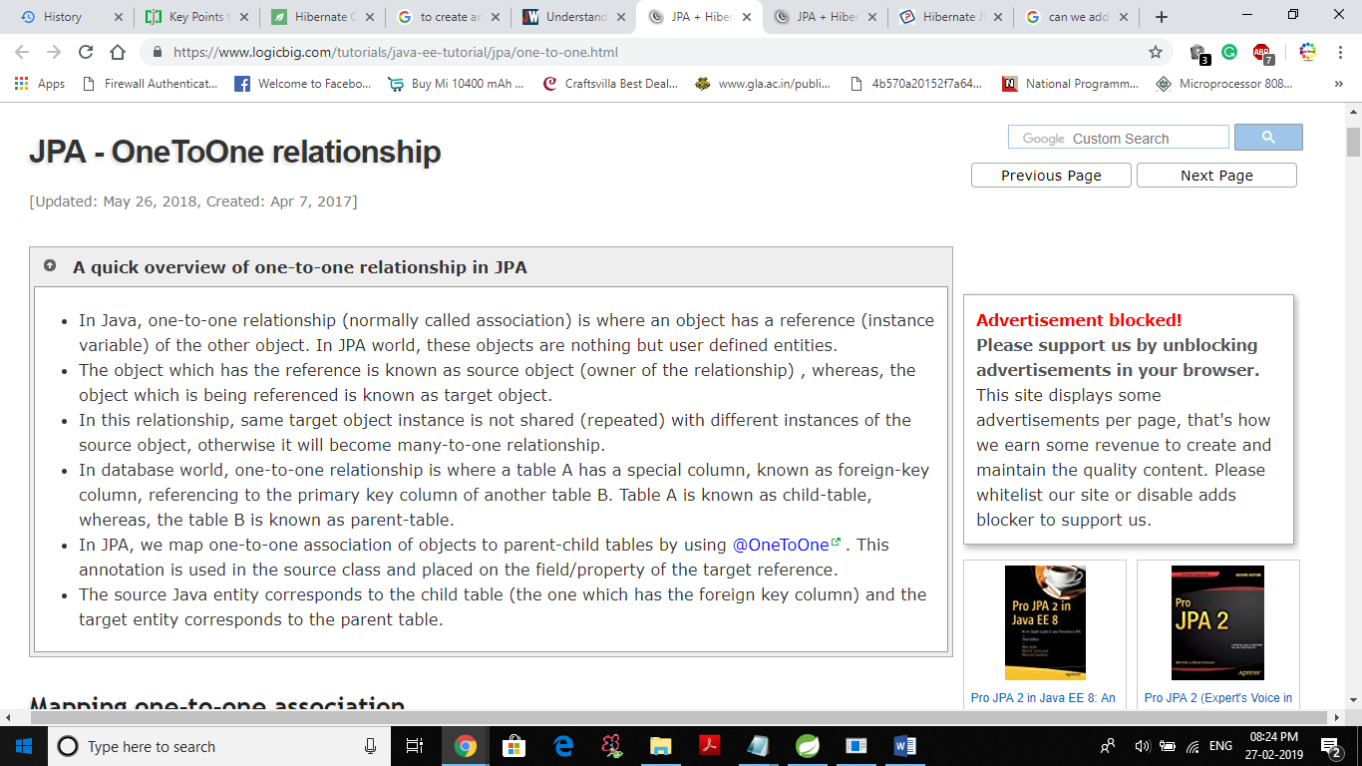

JPA - Bidirectional OneToOne relationship
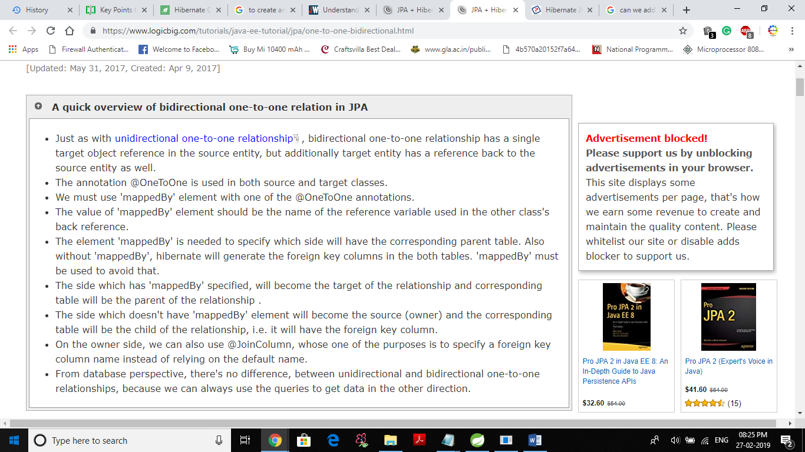

JPA - ManyToMany relationship
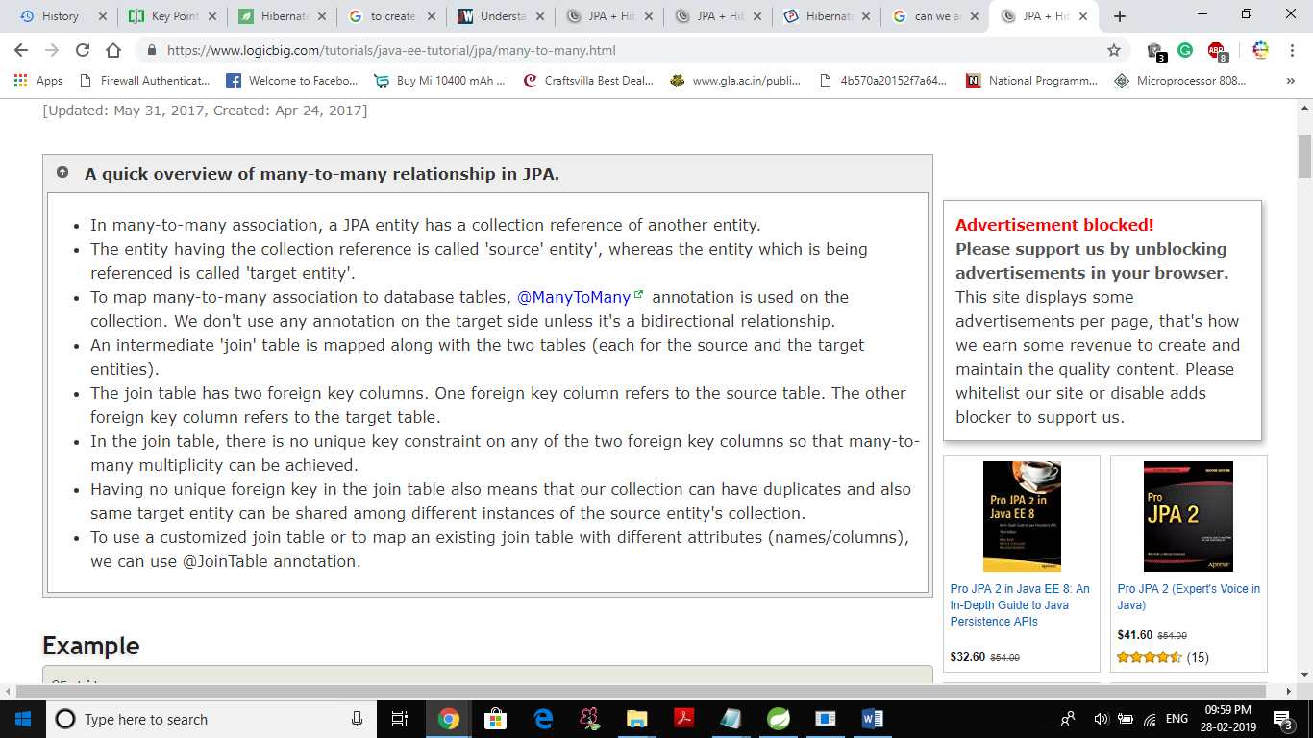

Untyped queries
Consider the following method of EntityManager:
public Query createQuery(String qlString);
Which can be used to get the query result by using following methods defined in Query class:
List getResultList();
Object getSingleResult();
As seen above both of the methods do not return the exact type of result (we have to do unsafe assignment/casting).

Typed Queries
To get typed result in JPQL, we can use following method of EntityManager
public <T> TypedQuery<T> createQuery(String qlString, Class<T> resultClass);
and then we can use following methods of TypedQuery<X>:
List<X> getResultList();
X getSingleResult();
TypedQuery is a subclass of Query.

Example
@Entity
public class Employee {
@Id
@GeneratedValue
private long id;
private String name;
private long salary;
@ManyToOne(cascade = CascadeType.ALL)
private Department dept;
.............
public static Employee create(String name, int salary, Department dept) {
Employee e = new Employee();
e.setName(name);
e.setSalary(salary);
e.setDept(dept);
dept.addEmployee(e);
return e;
}
.............
}
@Entity
public class Department {
@Id
@GeneratedValue
private long id;
private String name;
@OneToMany(mappedBy = "dept")
private List<Employee> employees;
.............
public void addEmployee(Employee e) {
if (this.employees == null) {
employees = new ArrayList<>();
}
employees.add(e);
}
.............
}

Using TypedQuery
public class ExampleMain {
private static EntityManagerFactory entityManagerFactory =
Persistence.createEntityManagerFactory("example-unit");

public static void main(String[] args) {
try {
persistEmployees();
findEmployees();
findEmployeeSalaries();
findDepartments();
findHighestSalaryDept();
} finally {
entityManagerFactory.close();
}
}

public static void persistEmployees() {
Department deptIt = new Department();
deptIt.setName("IT");

Department deptAdmin = new Department();
deptAdmin.setName("Admin");

Employee employee1 = Employee.create("Diana", 3000, deptIt);
Employee employee2 = Employee.create("Rose", 4000, deptAdmin);
Employee employee3 = Employee.create("Denise", 1500, deptIt);
Employee employee4 = Employee.create("Mike", 2000, deptAdmin);
EntityManager em = entityManagerFactory.createEntityManager();
em.getTransaction().begin();
em.persist(employee1);
em.persist(employee2);
em.persist(employee3);
em.persist(employee4);
em.getTransaction().commit();
em.close();
}

private static void findEmployees() {
System.out.println("-- all Employees--");
EntityManager em = entityManagerFactory.createEntityManager();
TypedQuery<Employee> query = em.createQuery("SELECT e FROM Employee e", Employee.class);
List<Employee> resultList = query.getResultList();
resultList.forEach(System.out::println);
}

private static void findEmployeeSalaries() {
System.out.println("-- Employee salaries --");
EntityManager em = entityManagerFactory.createEntityManager();
TypedQuery<Long> query = em.createQuery("SELECT e.salary FROM Employee e", Long.class);
List<Long> resultList = query.getResultList();
resultList.forEach(System.out::println);
}

private static void findDepartments() {
System.out.println("-- All dept departments --");
EntityManager em = entityManagerFactory.createEntityManager();
TypedQuery<Department> query = em.createQuery("SELECT d FROM Department d", Department.class);
List<Department> resultList = query.getResultList();
resultList.forEach(System.out::println);
}

private static void findHighestSalaryDept() {
System.out.println("-- Dept with max salary --");
EntityManager em = entityManagerFactory.createEntityManager();
TypedQuery<String> query = em.createQuery("SELECT d.name FROM Department d "
+ " JOIN d.employees e where e.salary = (SELECT MAX(e2.salary) FROM Employee e2) ",
String.class);
String dept = query.getSingleResult();
System.out.println(dept);
}
}
-- all Employees--
Employee{id=1, name='Diana', salary=3000, dept='IT'}
Employee{id=3, name='Rose', salary=4000, dept='Admin'}
Employee{id=5, name='Denise', salary=1500, dept='IT'}
Employee{id=6, name='Mike', salary=2000, dept='Admin'}
-- Employee salaries --
3000
4000
1500
2000
-- All dept departments --
Department{id=2, name='IT', employees=[Employee{id=1, name='Diana', salary=3000, dept='IT'}, Employee{id=5, name='Denise', salary=1500, dept='IT'}]}
Department{id=4, name='Admin', employees=[Employee{id=3, name='Rose', salary=4000, dept='Admin'}, Employee{id=6, name='Mike', salary=2000, dept='Admin'}]}
-- Dept with max salary --
Admin

What’s the difference between persist, save, merge and update? Which one should you use?
JPA and Hibernate provide different methods to persist new and to update existing entities. You can choose between JPA’s persist and merge and Hibernate’s save and update methods.
It seems like there are 2 pairs of 2 methods that do the same. You can use the methods persistand save to store a new entity and the methods merge and update to store the changes of a detached entity in the database. That’s why a lot of developers are wondering which of these methods they should use. Let’s take a closer look at the details and small differences of these methods.

Entity State Transitions
Before we get into the details of these 4 methods, I need to give you a quick introduction to JPA’s entity lifecycle states.

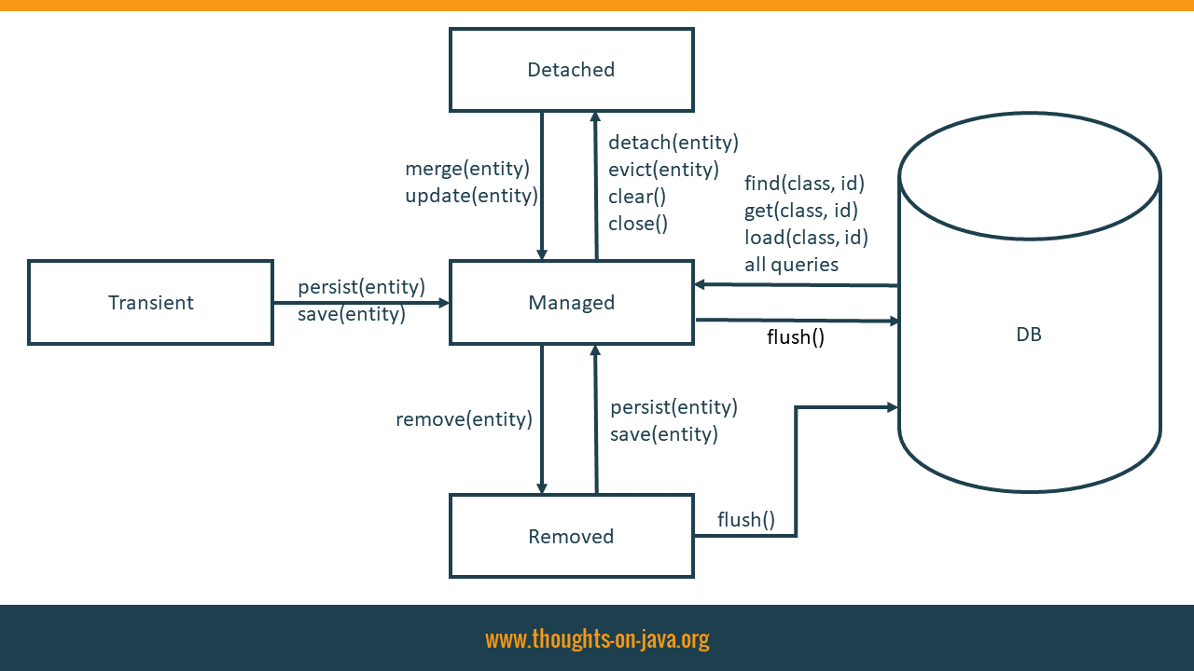

If an entity is attached to the current persistence context, it has the lifecycle state managed. That means that it is mapped to a database record. Your persistence provider generates the required SQL INSERT and UPDATE statements to propagate all changes. A managed entity is also stored in the 1st level cache.
When you create a new entity, it’s in the transient state. It remains in this state until you attach it to the current persistence context. I will show you how you can do that with JPA’s persist and Hibernate’s save method, in the following section. As long as an entity is in the transient state, it is not mapped to a database record and not managed by any persistence context.
Entities in the detached lifecycle state are no longer managed by the persistence context. That can be the case because you closed the persistence context or you explicitly detached the entity from the current context. I will get into more details about how you can reattach these entities with JPA’s merge and Hibernate’s update methods in a later part of this post.
And the last lifecycle state is removed. These entities were previously in the state managed,before you scheduled them for removal. Removing entities is outside of the scope of this post, so I will not get into too many details about it. You can schedule an entity for removal by calling the remove method on the EntityManager interface.

Persisting A New Entity Using persist Or save
When you create a new entity object, it’s in the transient lifecycle state. It does not map any database record.
1  2  3 | Author a = new Author();  a.setFirstName("Thorben");  a.setLastName("Janssen");
You need to attach the entity to a persistence context so that it becomes managed and gets persisted in the database. You can either use JPA’s persist or Hibernate’s save method to do that. Both methods seem to do the same, but there are a few differences.

Specification vs. Proprietary API
The most obvious difference is that the JPA specification defines the persist method. You can use it with all JPA implementations. The save method, on the other hand, is Hibernate-specific. It is, therefore, not available in other JPA implementations.
But that’s only relevant if you want to be able to replace Hibernate with another JPA implementation, like Eclipse Link or OpenJPA.

Return Types And Execution Of SQL Statements
Another obvious difference between these 2 methods is their return type. JPA’s persist method returns void and Hibernate’s save method returns the primary key of the entity.
That might seem like a huge difference, especially when you take a closer look at Hibernate’s Javadoc and the JPA specification:
- The Javadoc of Hibernate’s save method states that it generates the primary key value first:
Persist the given transient instance, first assigning a generated identifier.
Javadoc Session.save(entity)
- You don’t find any information about this in the JPA specification. It doesn’t define when the primary key value has to be assigned. So, the persistence provider can do that at any time between the call of the persist method and the flush of the persistence context.
In most cases, it doesn’t make any difference if you call the save or persist method. Hibernate uses the name of the entity class and the primary key value to store the entity in the first level cache. It, therefore, needs a primary key value when it executes the persist method.
In almost all situations, Hibernate generates the primary key value immediately and triggers an SQL statement if necessary, when you call the persist or save method.
But that is not the case if you use the IDENTITY strategy and try to persist an entity without an active transaction or with FlushMode.MANUAL. If you call the persist method in one of these situations, Hibernate delays the execution of the SQL INSERT statement and creates a temporary primary key value. But if you call the save method, Hibernate performs the SQL INSERT statement immediately and retrieves the primary key value from the database.
You can then retrieve it as the return value of the save method.
1  2  3  4  5 | Author a = new Author();  a.setFirstName("Thorben");  a.setLastName("Janssen");  Long id = (Long) em.unwrap(Session.class).save(a);
Or you can call the getter method of the primary key attribute of your managed entity if you use JPA’s persist method.
1  2  3  4  5  6  7 | Author a = new Author();  a.setFirstName("Torben");  a.setLastName("Janssen");  em.persist(a);  Long id = a.getId();
Hibernate executes the same SQL statements when you call the persist or the save method. Which and when it does that depends on your primary key generation strategy:

Not generated
If you set the primary key value programmatically, e.g. to a natural identifier, Hibernate only performs an SQL INSERT statement when it flushes the persistence context.
1  2  3  4  5  6  7  8  9 | 14:08:34,979 INFO TestPersistSaveMerge:237 - Save entity  14:08:35,052 INFO TestPersistSaveMerge:240 - Commit transaction  14:08:35,123 DEBUG SQL:92 -  insert  into  Author  (firstName, lastName, version, id)  values  (?, ?, ?, ?)

Watch this video on YouTube
Follow me on YouTube to not miss any new videos.

Generated with IDENTITY strategy
If you use the IDENTITY strategy to generate the primary key value, Hibernate needs to execute the INSERT statement when you call the save or persist method to retrieve the primary key value from the database.
1  2  3  4  5  6  7  8  9 | 14:09:28,264 INFO TestPersistSaveMerge:237 - Save entity  14:09:28,336 DEBUG SQL:92 -  insert  into  Author  (firstName, lastName, version)  values  (?, ?, ?)  14:09:28,354 INFO TestPersistSaveMerge:240 - Commit transaction

Watch this video on YouTube
Follow me on YouTube to not miss any new videos.

Generated with SEQUENCE strategy
And if you use the SEQUENCE, Hibernate performs an SQL SELECT statement to retrieve the next value from the database sequence. Hibernate then delays the INSERT statement until it flushes the persistence context. In this example, the flush happens when the transaction gets committed.
1  2  3  4  5  6  7  8  9  10  11  12 | 14:10:27,994 INFO TestPersistSaveMerge:237 - Save entity  14:10:28,002 DEBUG SQL:92 -  select  nextval ('hibernate_sequence')  14:10:28,042 INFO TestPersistSaveMerge:240 - Commit transaction  14:10:28,096 DEBUG SQL:92 -  insert  into  Author  (firstName, lastName, version, id)  values  (?, ?, ?, ?)

Generated with TABLE strategy
You shouldn’t use the TABLE strategy because it requires row level locks on the primary key table and doesn’t scale well. If you use this strategy anyways, Hibernate performs an SQL SELECT statement to retrieve the next primary key value from the database and writes the new value to the database table. It delays the execution of the SQL INSERT statement for the new entity until it flushes the persistence context.
1  2  3  4  5  6  7  8  9  10  11  12  13  14  15  16  17  18  19  20  21  22  23  24  25  26  27  28  29  30  31  32 | 14:11:17,368 INFO TestPersistSaveMerge:237 - Save entity  14:11:17,482 DEBUG SQL:92 -  select  tbl.next_val  from  hibernate_sequences tbl  where  tbl.sequence_name=? for update  of tbl  14:11:17,531 DEBUG SQL:92 -  insert  into  hibernate_sequences  (sequence_name, next_val)  values  (?,?)  14:11:17,534 DEBUG SQL:92 -  update  hibernate_sequences  set  next_val=?  where  next_val=?  and sequence_name=?  14:11:17,584 INFO TestPersistSaveMerge:240 - Commit transaction  14:11:17,655 DEBUG SQL:92 -  insert  into  Author  (firstName, lastName, version, id)  values  (?, ?, ?, ?)

Which one to choose?
You could expect that the save and persist method behave differently because there are a few differences between the JPA specification and the Javadoc of Hibernate’s proprietary methods.
But almost all of these differences disappear when you take a look at the internal implementation. The only ones that remain are 2 corner cases in which Hibernate might delay the retrieval of the primary key, the return type of the method and the support by other JPA implementations.
For most applications, it doesn’t make any difference if you get the generated primary key value as the return type of Hibernate’s save method or from the getter method of your primary key attribute. As long as you don’t use an extended persistence context and perform all database operations with an active transaction, I recommend using JPA’s persist method.

Updating a detached entity
When you close the current persistence context or explicitly remove an entity from it by calling the clear or detach methods on the EntityManager interface, the entity becomes detached. That means that it is no longer stored in the 1st level cache and that Hibernate will not replicate any of the applied changes to the database.
You can use Hibernate’s update or JPA’s merge method to associate a detached entity with a persistence context. After you’ve done that, Hibernate will update the database based on the entity attribute values.
The effect of the update and merge method seem to be the same, but as you will see in the following sections, there is an important difference.

JPA’s merge method
JPA’s merge method copies the state of a detached entity to a managed instance of the same entity. Hibernate, therefore, executes an SQL SELECT statement to retrieve a managed entity from the database. If the persistence context already contained a managed instance of the entity, Hibernate uses the existing one instead. It then copies all attribute values to the managed entity and returns it to the caller.
1 | Author managedAuthor = em.merge(a);
After activating the logging of SQL statements, you can see the executed SELECT and UPDATE statements in the log output.
1  2  3  4  5  6  7  8  9  10  11  12  13  14  15  16  17  18  19  20  21  22  23  24  25  26  27  28  29  30  31  32  33  34  35 | 11:37:21,172 DEBUG SQL:92 -  select  books0_.bookId as bookId1_2_0_,  books0_.authorId as authorId2_2_0_,  book1_.id as id1_1_1_,  book1_.fk_author as fk_autho6_1_1_,  book1_.format as format2_1_1_,  book1_.publishingDate as publishi3_1_1_,  book1_.title as title4_1_1_,  book1_.version as version5_1_1_,  author2_.id as id1_0_2_,  author2_.firstName as firstNam2_0_2_,  author2_.lastName as lastName3_0_2_,  author2_.version as version4_0_2_  from  BookAuthor books0_  inner join  Book book1_  on books0_.authorId=book1_.id  left outer join  Author author2_  on book1_.fk_author=author2_.id  where  books0_.bookId=?  11:37:21,180 INFO TestPersistSaveMerge:82 - Before commit  11:37:21,182 DEBUG SQL:92 -  update  Author  set  firstName=?,  lastName=?,  version=?  where  id=?  and version=?
When Hibernate flushes the persistence context for the next time, its dirty checking mechanism checks all managed entities. If it detects that the merge operation changed any entity attribute value, it triggers the required SQL UPDATE statement.
There is one important detail you need to know when you use JPA’s merge method. Hibernate copies the attribute values of the detached entity to the managed entity. This overwrites any changes that you performed on this entity within the current Session.

Hibernate’s update method
Hibernate’s update method doesn’t trigger an SQL SELECT statement. It just attaches the entity to the current persistence context. In contrast to JPA’s merge method, you can’t lose any changes by calling the update method. If the persistence context already contains a managed instance of the entity you want to update, it throws an exception.
1 | em.unwrap(Session.class).update(a);
When Hibernate performs the next flush, it doesn’t perform any dirty checks. That’s not possible because Hibernate didn’t read the latest version of the entity from the database. It just executes an SQL UPDATE statement for the reattached entity.
1  2  3  4  5  6  7  8  9  10  11 | 11:38:28,151 INFO TestPersistSaveMerge:121 - Before commit  11:38:28,153 DEBUG SQL:92 -  update  Author  set  firstName=?,  lastName=?,  version=?  where  id=?  and version=?
The missing dirty check causes an unnecessary SQL UPDATE statement when the entity and the corresponding database record contain the same values. This might be a problem if your DBA registered an update trigger for the database table. In these situations, you can annotate your entity with @SelectBeforeUpdate.
1  2  3 | @Entity  @SelectBeforeUpdate  public class Author { ... }
That tells Hibernate to select the entity and perform a dirty check before it generates the SQL UPDATE statement. As you can see in the log output, the behavior of the update method is now similar to JPA’s merge method.
1  2  3  4  5  6  7  8  9  10  11  12  13  14  15  16  17  18  19  20  21 | 19:08:16,530 INFO TestPersistSaveMerge:121 - Before commit  19:08:16,531 DEBUG SQL:92 -  select  author_.id,  author_.firstName as firstNam2_0_,  author_.lastName as lastName3_0_,  author_.version as version4_0_  from  Author author_  where  author_.id=?  19:08:16,592 DEBUG SQL:92 -  update  Author  set  firstName=?,  lastName=?,  version=?  where  id=?  and version=?
But there is a significant difference between the 2 methods. When you call the update method, Hibernate will only select the entity which you provided as a method parameter. But when you call JPA’s merge method, Hibernate will also select all associations with CascadeType.MERGE. You should, therefore, prefer JPA’s merge method if you reattach a huge graph of entities.

Which one to choose?
There is no general answer to this questions. As you have seen, both methods have their advantages and disadvantages. You have to decide for your specific use case if Hibernate needs to select the entity before it triggers the SQL UPDATE statement. And if that’s the case, you also need to consider the depth of your entity graph and the performance implications of the provided fetching behavior.

Updating a managed entity
JPA and Hibernate make it very easy to update a managed entity. If your entity is in the lifecycle state managed, e.g. because you fetched it with a JPQL query or the find method of the EntityManager, you just need to change the values of your entity attributes.
1  2  3  4  5  6  7  8  9 | em = emf.createEntityManager();  em.getTransaction().begin();  a = em.find(Author.class, a.getId());  a.setFirstName("Thorben");  log.info("Before commit");  em.getTransaction().commit();  em.close();
When Hibernate decides to flush the persistence context, the dirty checking mechanism will detect the change and perform the required SQL UPDATE statement.
1  2  3  4  5  6  7  8  9  10  11  12  13  14  15  16  17  18  19  20  21 | 11:41:49,178 DEBUG SQL:92 -  select  author0_.id as id1_0_0_,  author0_.firstName as firstNam2_0_0_,  author0_.lastName as lastName3_0_0_,  author0_.version as version4_0_0_  from  Author author0_  where  author0_.id=?  11:41:49,191 INFO TestPersistSaveMerge:335 - Before commit  11:41:49,193 DEBUG SQL:92 -  update  Author  set  firstName=?,  lastName=?,  version=?  where  id=?  and version=?
You don’t need to, and you should not call Hibernate’s save method after you updated an entity. That triggers an additional SaveOrUpdate event without providing any benefits. When Hibernate decides to flush the persistence context, it will perform the dirty check anyway to detect all changes before it executes the required SQL UPDATE statements.

Example 10.1. Delete by Query
Query q = em.createQuery ("DELETE s FROM Subscription s WHERE s.subscriptionDate < :today");
q.setParameter ("today", new Date ());
int deleted = q.executeUpdate ();

10.1.11. Update By Query
Similar to bulk deletes, it is sometimes necessary to perform updates against a large number of queries in a single operation, without having to bring all the instances down to the client. Rather than bring these objects into memory and modifying them individually, JPA allows you to perform a single bulk update based on JPQL criteria.
Update by query uses the same JPQL syntax as normal queries, except that the query string begins with the update keyword instead of select. To execute the update, you call the following Query method:
public int executeUpdate ();
This method returns the number of objects updated. The following example updates all subscriptions whose expiration date has passed to have the "paid" field set to true.

Example 10.2. Update by Query
Query q = em.createQuery ("UPDATE Subscription s SET s.paid = :paid WHERE s.subscriptionDate < :today");
q.setParameter ("today", new Date ());
q.setParameter ("paid", true);
int updated = q.executeUpdate ();

JPA: DELETE WHERE does not delete children and throws an exception
Ask Question
24
7
I am trying to delete a large number of rows from MOTHER thanks to a JPQL query.
The Mother class is defined as follows:
@Entity
@Table(name = "MOTHER")
public class Mother implements Serializable {

@OneToMany(cascade = CascadeType.ALL, mappedBy = "mother",
orphanRemoval = true)
private List<Child> children;
}

@Entity
@Table(name = "CHILD")
public class Child implements Serializable {

@ManyToOne
@JoinColumn(name = "MOTHER_ID")
private Mother mother;
}
As you can see, the Mother class has "children" and when executing the following query:
String deleteQuery = "DELETE FROM MOTHER WHERE some_condition";
entityManager.createQuery(deleteQuery).executeUpdate();
an exception is thrown:
ERROR - ORA-02292: integrity constraint <constraint name> violated -
child record found
Of course, I could first select all the objects I want to delete and retrieve them into a list before iterating through it to delete all the retrieved object, but the performance of such a solution would just be terrible!
So is there a way to take advantage of the previous mapping to delete all the Mother objects AND all the Child objects associated with them efficiently and without writing first the queries for all the children?
java hibernate jpa jpql
shareimprove this question
edited Oct 19 '11 at 18:25



DataNucleus
14.6k22836
asked Oct 19 '11 at 17:33



Jean Logeart
42.5k105795
add a comment

5 Answers
activeoldestvotes
31
DELETE (and INSERT) do not cascade via relationships in JPQL query. This is clearly spelled in specification:
A delete operation only applies to entities of the specified class and its subclasses. It does not cascade to related entities.
Luckily persist and removal via entity manager do (when there is cascade attribute defined).
What you can do:
- fetch all Mother entity instances that should be removed.
- for each of them call EntityManager.remove().
Code is something like this:
String selectQuery = "SELECT m FROM Mother m WHERE some_condition";
List<Mother> mothersToRemove = entityManager.createQuery(selectQuery).getResultList();
for (Mother m: mothersToRemove) {
em.remove(m);
}

